PRODUCT RESEARCH PAPER
Access Obsidian / Cipher
Strike Matrix, Night Vision, Setup Scanner, inferred weighting, and rebuild methodology
Field | Value
Audit target | https://www.accessobsidian.com/app#SLV
Observed title | Cipher - Strike Matrix
Audit date | July 18, 2026, America/New_York
Method | Authenticated Chrome UI exploration, screenshot evidence, DOM/control inventory, non-destructive interaction testing, and inferred model reconstruction.
Preset | standard_business_brief

Scope note
Exact proprietary model weights were not exposed by the UI. This paper separates observed behavior from inferred formulas and reconstruction weights.

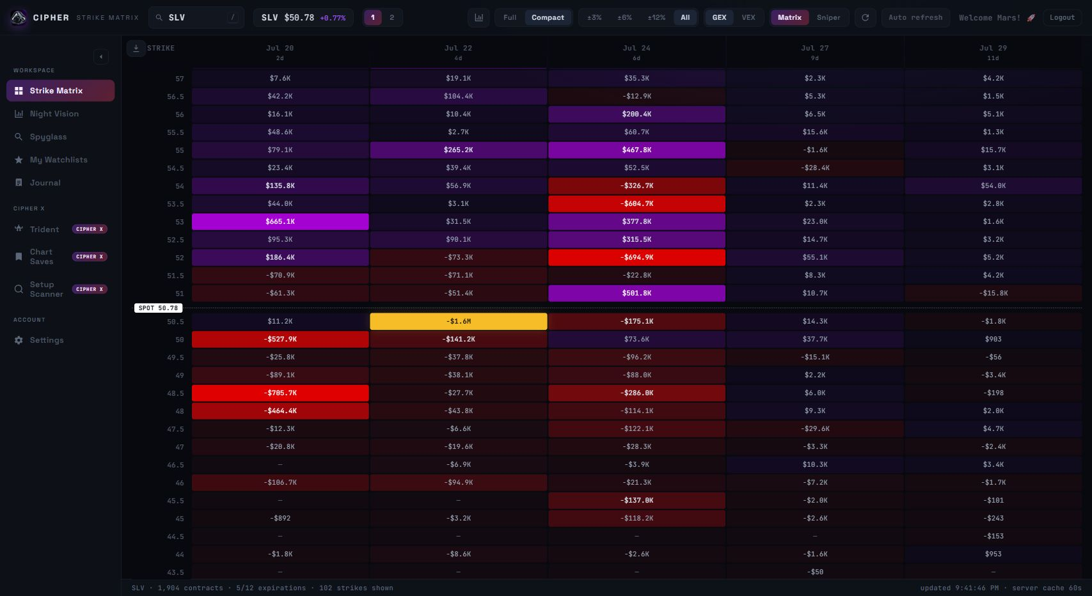
Figure 1. Strike Matrix baseline for SLV showing strike rows, expiration columns, spot marker, and exposure heatmap.

Executive Summary
Cipher is best understood as a trading workstation built around three analytical layers: Strike Matrix for exposure structure, Night Vision for chart translation, and Setup Scanner for opportunity discovery. The rest of the product - watchlists, chart saves, journal, and settings - supports this core loop.
Main conclusion
A functional clone can be built by combining options-chain greeks, open interest, volume, expiration decay, distance-to-spot, volume profile, VWAP/session levels, and flow confirmation. Exact weights cannot be proven from the UI alone, but they can be estimated through rank-learning if enough input/output examples are collected.

System | Primary job | Rebuild focus
Strike Matrix | Map option exposure by strike and expiration. | Aggregate GEX/VEX, normalize cell intensity, identify top pull, floors, ceilings, clusters, and runway.
Night Vision | Translate matrix levels onto price charts. | Render candles plus exposure bands, X-Ray rows, volume profile, live flow, and multi-timeframe controls.
Setup Scanner | Rank candidates across the universe. | Score tickers using level strength, runway, clusters, flow, volume profile, liquidity, spreads, and horizon-specific weighting.

Methodology
- Browser surface: Chrome was used against the live authenticated app at the supplied Access Obsidian URL.
- Evidence: Screenshots were captured for the active screens, scanner states, responsive layouts, and key workbench controls.
- Interaction safety: State-changing actions such as saving charts, submitting feedback, editing journal entries, adding watchlist items, downloading CSVs, logging out, and connecting/disconnecting credentials were intentionally avoided.
- Inference boundary: Model formulas and weights below are reconstruction hypotheses derived from visible labels, outputs, tooltips, and standard options-risk mechanics.

Strike Matrix: How It Works
Strike Matrix is the app's structural core. It converts an option chain into a strike-by-expiration heatmap. Rows are strikes, columns are expirations, and each cell represents an aggregated exposure value. The spot marker anchors the entire read.
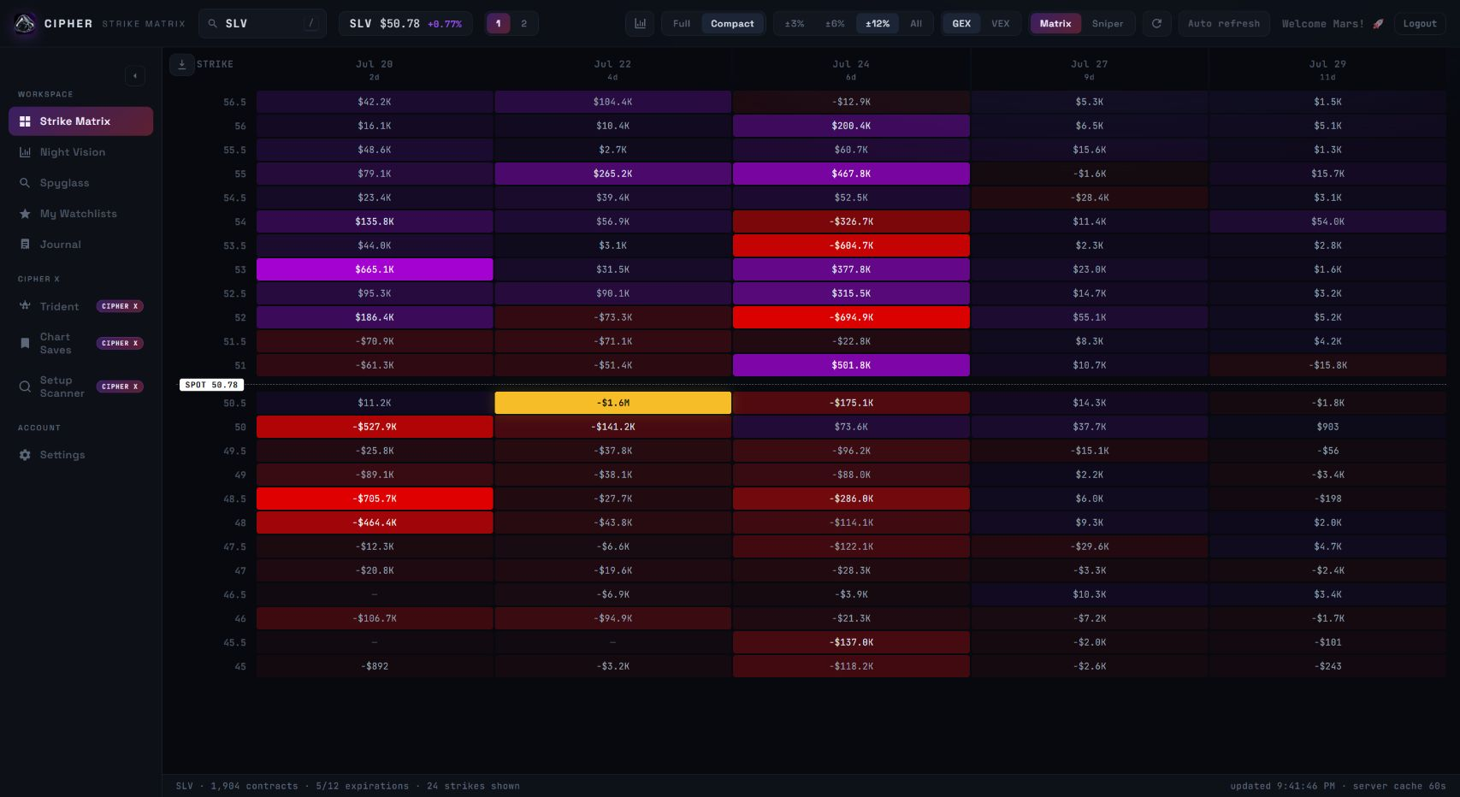
Figure 2. Strike Matrix after mode/range toggles, showing compact heatmap behavior and top-level controls.

Observed Reading Flow
- Start at spot. The matrix marks current price, observed as SPOT 50.78 for SLV, so the trader can immediately separate above-spot and below-spot levels.
- Find dominant cells. Large absolute values and saturated color indicate the strongest levels. These become candidate walls, floors, magnets, danger zones, or targets depending on sign and metric.
- Compare expirations. Repeated levels across columns are more structural; isolated bright cells are more event- or expiration-specific.
- Switch metric. GEX likely emphasizes gamma pressure and near-price hedging behavior. VEX likely emphasizes volatility/vega exposure.
- Control distance. +/-3%, +/-6%, +/-12%, and All change how wide the visible battlefield is around spot.

Likely Formula Layer
contract_gex = gamma * open_interest * contract_multiplier * spot^2 * sign
contract_vex = vega * open_interest * contract_multiplier * volatility_move_unit * sign
cell_gex[strike, expiration] = sum(contract_gex at strike/expiration)
cell_vex[strike, expiration] = sum(contract_vex at strike/expiration)
visual_intensity = abs(cell_value) / max(abs(cell_value) in current view)

The sign convention is not exposed. A rebuild must decide whether sign is customer-side, dealer-side, call/put based, or derived from trade/open-interest assumptions. The UI proves that positive and negative cell values exist; it does not reveal the convention.

Derived Level Weights
level_strength =
0.45 * normalized_abs_gex
+ 0.20 * normalized_abs_vex
+ 0.15 * expiration_weight
+ 0.10 * open_interest_weight
+ 0.10 * recency_or_volume_weight

Derived level | Purpose | Reconstruction logic
Nearest floor | Most relevant supportive level below spot. | Max level_strength below spot within selected range.
Nearest ceiling | Most relevant resistance level above spot. | Max level_strength above spot within selected range.
Top pull | Dominant attraction/pressure level. | Highest absolute level_strength in the selected expiration/range.
Golden level | Dominant centering level used by Snap to golden. | Likely top pull or strongest cluster centroid.
Runway | Measures open path from spot to target. | Distance to dominant level discounted by opposing levels between spot and target.
Cluster score | Density of important levels. | Count/weight of strong levels inside a narrow strike band.

Matrix vs. Sniper
Matrix appears to be the full structural heatmap. Sniper appears to be a reduced, execution-focused mode that emphasizes nearest floors, nearest ceilings, top-pull levels, and unusually strong near-spot zones.
include_in_sniper if:
abs(level_strength) >= percentile_85
OR distance_to_spot <= near_spot_threshold and abs(level_strength) >= percentile_65
OR level is nearest_floor / nearest_ceiling / top_pull

Night Vision: How It Works
Night Vision is the chart-translation layer. It takes matrix-derived levels and overlays them on price charts so the trader can see whether price is rejecting, accepting, approaching, or moving through exposure zones.
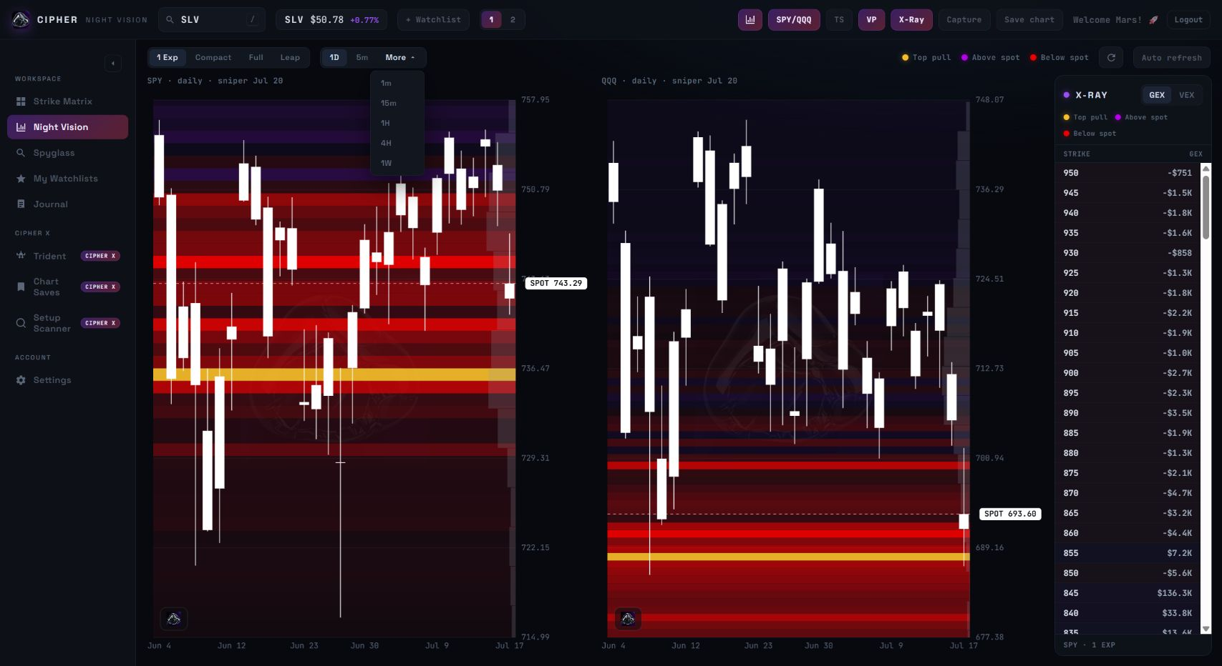
Figure 3. Night Vision with SPY/QQQ split, X-Ray, volume profile, and timeframe menu exposed.

Core Components
Component | Observed role | Rebuild implementation
Candlestick chart | Base price action surface. | Canvas or WebGL renderer using OHLC candles.
Exposure bands | Matrix levels projected onto chart y-axis. | Horizontal bands colored by sign and opacity by strength.
X-Ray panel | Exact numeric inspection of strike/value rows. | Scrollable table synchronized to selected metric and expiration depth.
Volume profile | POC/HVN/LVN and bounce-edge context. | Volume-by-price histogram aligned with chart price scale.
SPY/QQQ split | Market-index comparison mode. | Two synchronized chart panes with independent levels.
Trade tape | Live flow confirmation. | Filtered prints by size, side, date, and combined SPY/QQQ stream.

Overlay Weighting
chart_band_opacity =
0.55 * normalized_abs_exposure
+ 0.20 * proximity_to_spot
+ 0.15 * selected_expiration_relevance
+ 0.10 * recent_touch_reaction_score
chart_level_importance =
0.70 * exposure_level_strength
+ 0.30 * volume_profile_confirmation

The app's visual logic suggests that exposure strength is primary, while proximity, expiration relevance, and reaction behavior refine which bands matter most on the active chart.

Ghost Projection
The Ghost control is described by the UI as a next-15-minute projection from the dealer hedging surface for SPY/QQQ. Its exact behavior was not verified because interaction timed out, but a functional recreation could treat it as a short-horizon pressure model rather than an absolute price prediction.
ghost_direction =
weighted_sum(
distance_to_nearest_floor,
distance_to_nearest_ceiling,
net_gex_gradient_near_spot,
recent_momentum,
last_5_min_flow
)

Setup Scanner: How It Works
Setup Scanner is the discovery engine. It ranks the universe and surfaces candidates before the user chooses a ticker manually. It should feed the rest of the workflow: scanner result to Strike Matrix, then Night Vision, then Chart Saves/Journal/Watchlists.
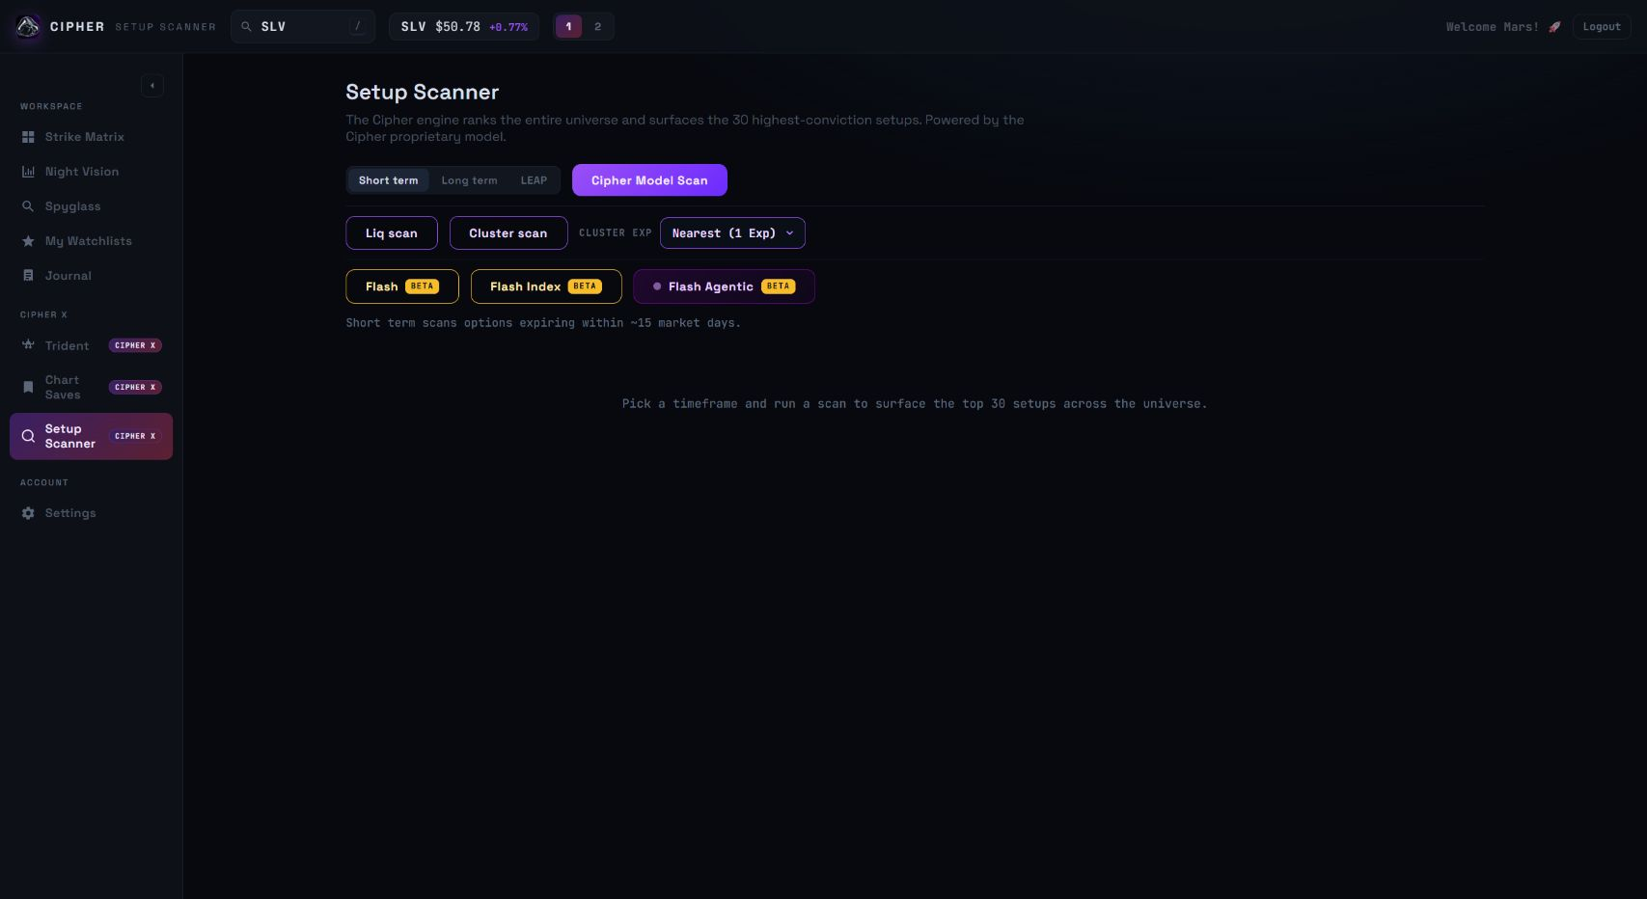
Figure 4. Setup Scanner showing horizon, model, liquidity, cluster, and Flash beta controls.

Model Families
Mode | Observed description | Likely scoring focus
Short term | Options expiring within about 15 market days. | Nearest-exp exposure, flow, momentum, spread quality.
Long term | Farther-dated setup search. | Multi-expiration clusters, OI persistence, trend alignment.
LEAP | Long-dated optionality. | Long-dated OI, VEX, liquidity, macro trend context.
Cipher Model Scan | General top-30 proprietary ranker. | Blended level strength, runway, cluster, flow, VP, liquidity.
Liq scan | Liquidity-vacuum runway. | Dominant far level, thin path, second stacked line, tradability.
Cluster scan | Clustered levels by selected expiration. | Level density, cross-expiration agreement, proximity, cleanliness.
Flash | Intraday beta model. | GEX/VEX floors, session levels, VP, VWAP, momentum, reaction, last-5-min flow.
Flash Index | Flash model for QQQ, SPY, IWM. | Same as Flash, restricted to index ETFs.
Flash Agentic | Living monitor that surfaces armed/triggered setups. | State machine and confidence threshold.

General Scanner Weighting
cipher_score =
0.25 * level_strength_score
+ 0.20 * runway_score
+ 0.15 * cluster_score
+ 0.15 * flow_confirmation
+ 0.10 * volume_profile_confirmation
+ 0.10 * liquidity_score
+ 0.05 * spread_quality

Specialized Scan Weights
liq_scan_score =
0.40 * dominant_level_distance_score
+ 0.30 * path_thinness_score
+ 0.20 * stacked_second_line_score
+ 0.10 * tradability_score
cluster_scan_score =
0.45 * level_density
+ 0.25 * cross_expiration_agreement
+ 0.15 * proximity_to_spot
+ 0.15 * directional_cleanliness
flash_score =
0.18 * nearest_exp_gex_floor_ceiling
+ 0.14 * nearest_exp_vex_floor_ceiling
+ 0.12 * session_key_level_alignment
+ 0.12 * volume_profile_alignment
+ 0.12 * vwap_position
+ 0.12 * momentum
+ 0.10 * touch_reaction
+ 0.10 * last_5_min_flow
+ 0.10 * atr_target_quality

Flash Agentic State Machine
dormant -> arming -> triggered -> target_1_hit -> target_2_hit -> completed
-> failed / cooled
show candidate only if:
state in [arming, triggered, target_1_hit, target_2_hit]
AND confidence_score >= threshold

Can The Weights Be Calculated?
The exact proprietary weights cannot be proven from screenshots alone. They can, however, be estimated if enough paired input/output examples are captured. This is a rank-learning problem: collect the factors the app likely uses, collect the app's visible rankings/highlights, then fit weights that best reproduce those outputs.
Evidence level | What it can answer | Required data
Exact | True internal weights and formulas. | Source code, internal docs, or exposed formula endpoints.
Estimated | Weights that best explain observed rankings. | Many scanner outputs plus raw option/price/flow features.
Functional clone | A model that behaves similarly enough for rebuild. | Tuned formulas and validation against visible app outputs.

Best Estimation Workflow
- Collect outputs. Capture scanner rankings, matrix top-pull levels, X-Ray rows, and highlighted cells across many tickers and dates.
- Build features. Compute GEX, VEX, distance to spot, expiration decay, OI, volume, spread quality, IV, ATR, VWAP, and flow confirmation.
- Fit models. Use linear regression for transparent weights, gradient boosting for nonlinear behavior, and pairwise rank-learning for scanner order.
- Validate. Compare predicted top names, highlighted levels, floors/ceilings, and scanner ordering against the app.
- Tune. Adjust feature transformations until the clone reproduces the app's visible behavior within an acceptable error band.

Completed Scan: First-Pass Visible-Field Estimate
The primary Cipher Model Scan completed with 30 parsed ranked rows. A standardized regression over visible output fields explained 32.2% of the displayed 0-100 score variance. That means the visible result-card fields are informative but not sufficient to recover the true model; hidden inputs such as raw GEX, VEX, OI, IV, spread quality, flow, VWAP, ATR, and full-universe comparisons likely explain the rest.
Visible feature | Std. coefficient | Correlation to score
vacuum_count | -4.363 | -0.132
near_gap_pct | 0.846 | -0.013
pull_from_support_pct | -1.087 | 0.050
stretch_from_support_pct | -0.036 | 0.037
support_count | 5.023 | 0.221
resistance_count | 0.000 | 0.000

Interpretation: in this single completed LEAP-horizon scan, visible fields alone only partially explain score. The negative coefficient on vacuum_count should not be read as 'fewer targets are always better'; it is likely a symptom of score compression, collinearity, and missing raw model inputs. The correct next step is repeated data collection plus rank-learning against raw feature vectors.
Rank | Ticker | Dir. | Score | Supports | Resistances | Pull
1 | LAES | BULLISH | 82 | 2.5, 2.0 | 3.0, 3.5 | 3.0
2 | PCG | BULLISH | 79 | 16.5, 16.0 | 17.5, 18.0 | 20.0
3 | IOVA | BULLISH | 78 | 4.5, 4.0 | 5.5, 7.5 | 5.5
4 | AXTI | BULLISH | 76 | 43.0, 40.0 | 49.5, 50.0 | 50.0
5 | HIVE | BULLISH | 73 | 2.5, 2.0 | 3.0, 3.5 | 4.0
6 | NUAI | BULLISH | 73 | 4.0, 3.5 | 4.5, 5.0 | 4.5
7 | CSCO | BULLISH | 72 | 109.0, 108.0 | 112.0, 114.0 | 120.0
8 | CLOV | BULLISH | 71 | 4.0, 4.5 | 5.0, 5.5 | 5.0
9 | WULF | BULLISH | 71 | 17.0, 16.0 | 18.5, 19.0 | 20.0
10 | HIMS | BULLISH | 70 | 31.0, 30.5 | 33.0, 34.0 | 40.0

Rebuild Blueprint

Data Inputs
- Options chain by ticker, expiration, strike, side, bid, ask, mark, open interest, volume, IV, delta, gamma, vega.
- Underlying spot and OHLC candles across intraday and daily timeframes.
- VWAP, ATR, premarket high/low, prior day high/low, prior week high/low, and session metadata.
- Live or delayed options trades for tape classification and last-5-minute flow.
- Volume-by-price data for volume profile.
- Universe lists for liquid names, index ETFs, low-IV institutional names, and scanner-eligible tickers.

Suggested API Shapes
GET /api/matrix?ticker=SLV&metric=gex&depth=compact&expirations=5
GET /api/hot-strikes?ticker=SLV&metric=gex&mode=sniper
GET /api/night-vision?ticker=SLV&timeframe=1d&depth=1exp
GET /api/scanner?model=cipher&horizon=short
GET /api/scanner/flash?universe=liquid
GET /api/watchlist
POST /api/chart-saves
POST /api/journal/day

Matrix Response Schema
{
ticker,
spot,
updated_at,
cache_seconds,
expirations: [{ date, days_to_expiration }],
strikes: [50, 50.5, 51, ...],
cells: [{ strike, expiration, gex, vex, intensity, role }],
derived: {
nearest_floor,
nearest_ceiling,
top_pull,
golden_level,
pin_score,
runway_score
}
}

Scanner Result Schema
{
ticker,
score,
direction,
model,
horizon,
trigger,
target_1,
target_2,
structural_wall,
nearest_floor,
nearest_ceiling,
expiration,
reasons: [
"thin runway to dominant upside level",
"cluster confirmed on nearest weekly",
"VWAP and flow aligned"
],
state
}

Supporting Features
Feature | Role in workflow | Implementation note
Watchlists | Hold promoted names and monitor daily move/level context. | Need add/remove confirmation and undo.
Journal | Record P/L, mistakes, lessons, and trade thesis. | Clear day and Save day should have strong state feedback.
Chart Saves | Persist Night Vision snapshots for review. | Store ticker, timestamp, timeframe, overlays, top-pull, and cache age.
Settings | Manage plan, refresh preferences, Alpaca data connection, feedback. | Credential-like fields should be masked and redaction-friendly.
Responsive mode | Mobile monitoring rather than full terminal. | Use summary cards and drill-ins instead of overlaying sidebar over matrix.

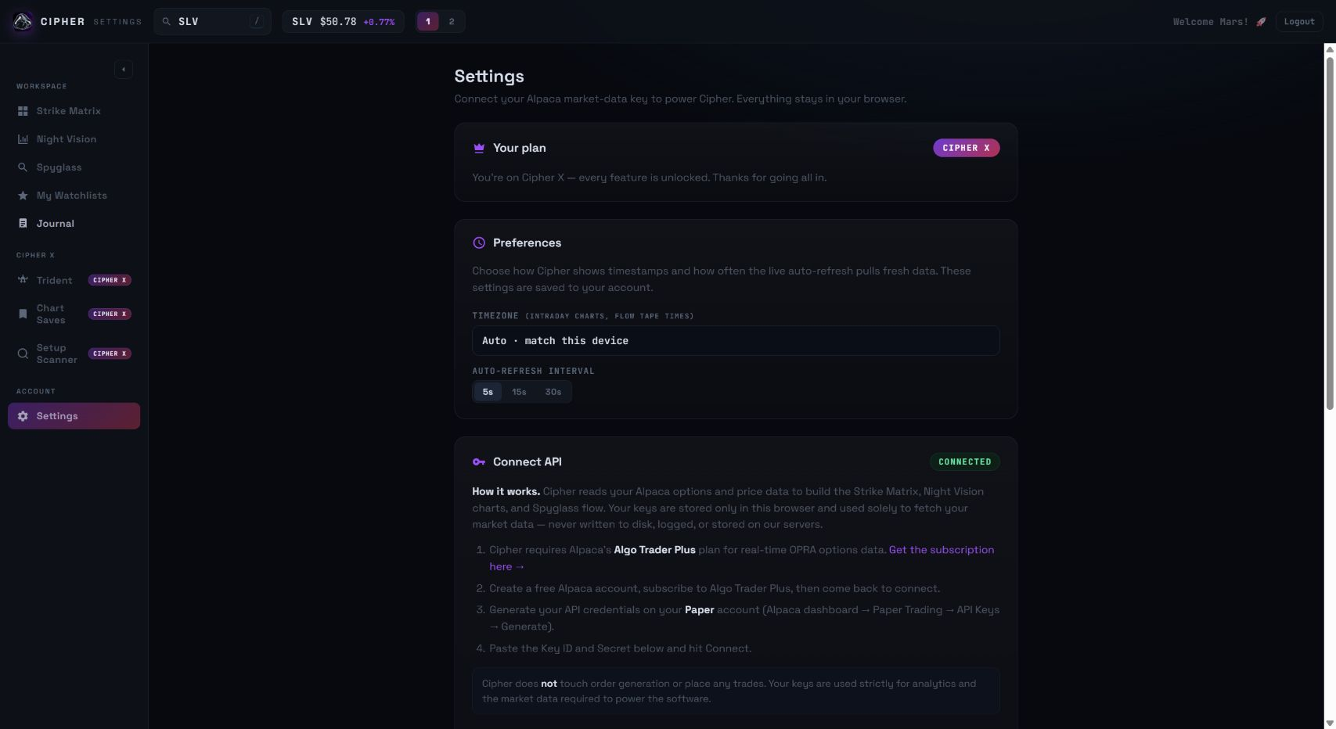
Figure 5. Settings screen with plan state, preferences, and API connection area.
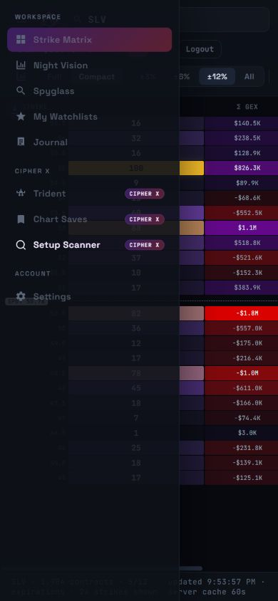
Figure 6. Mobile Strike Matrix check showing sidebar/content occlusion risk.

Priority Recommendations
- Expose explainability. Every highlighted level and scanner card should show its top contributing factors.
- Harden sensitive-field handling. Mask credential-like values by default and use explicit reveal/copy actions.
- Make inactive panels inert. Hidden DOM panels should not interfere with keyboard, screen readers, or automation.
- Strengthen scanner states. Show active mode, loading state, result count, timestamp, and empty-state reason.
- Improve toggle semantics. Use visible active states plus aria-pressed for X-Ray, VP, TS, Ghost, Node Galaxy, Matrix, and Sniper.
- Reduce color-only semantics. Add text labels, legends, and optional colorblind palettes.
- Design mobile as a separate surface. Provide monitoring summaries and fullscreen detail drill-ins, not a compressed desktop terminal.

Appendix: Screenshot Evidence
File | Evidence role
01-baseline-fullpage.png | Initial authenticated app state.
02-strike-matrix.png | Strike Matrix baseline.
15-night-overlays.png | Night Vision overlays and X-Ray.
19-setup-scanner-revisit.png | Setup Scanner controls.
17-ticker-aapl.png | Ticker search changed URL/hash to AAPL.
18-ticker-slv-restored.png | Ticker restored to SLV.
34-mobile-strike.png | Mobile responsive check.
35-tablet-strike.png | Tablet responsive check.

